**Experiment 1.3**

**Student Name: Gaurav Kumar                                                         UID: 22MCC20177**

**Branch: University Institute Of Computing                                   Section/Group: 1/B**

**Semester: 1                                                                    Date of Performance: 12/11/2022**

**Subject Name: Design And Analysis Of Algorithm                    Subject Code: 22CAP-646**

**Task to be done:**

Implement a two way Merge Sort algorithm to sort a given set of elements in descending order and determine the time required to sort the elements. Repeat the experiment for different values of n, the number of elements in the list to be sorted and plot a graph of the time taken versus n. The elements can be read from a file

**Steps for experiment/practical: copy and paste your code here/screenshots**

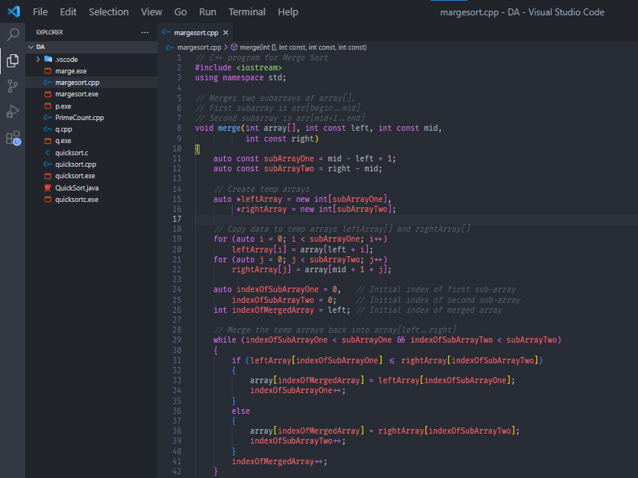

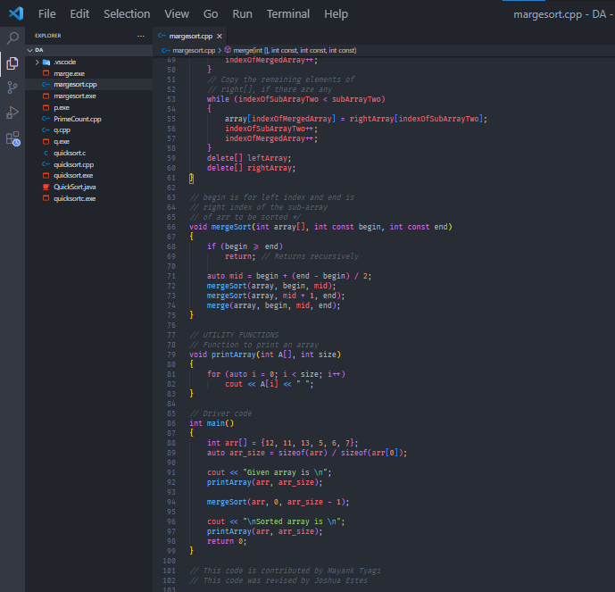

1. **Output (screenshots)**

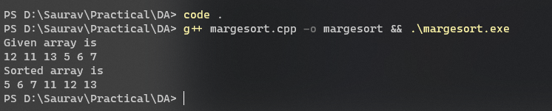

**4) Learning outcomes (What I have learnt):**

**I have learnt about how to sort array elements using merge sort and also how to calculate time complexity.**

**Evaluation Grid:**

|  |  |  |  |
| --- | --- | --- | --- |
| Sr. No. | Parameters | Marks Obtained | Maximum Marks |
| 1. | Demonstration and Performance  (Quiz) |  | 22 |
| 2. | Worksheet |  | 8 |